**Design:**

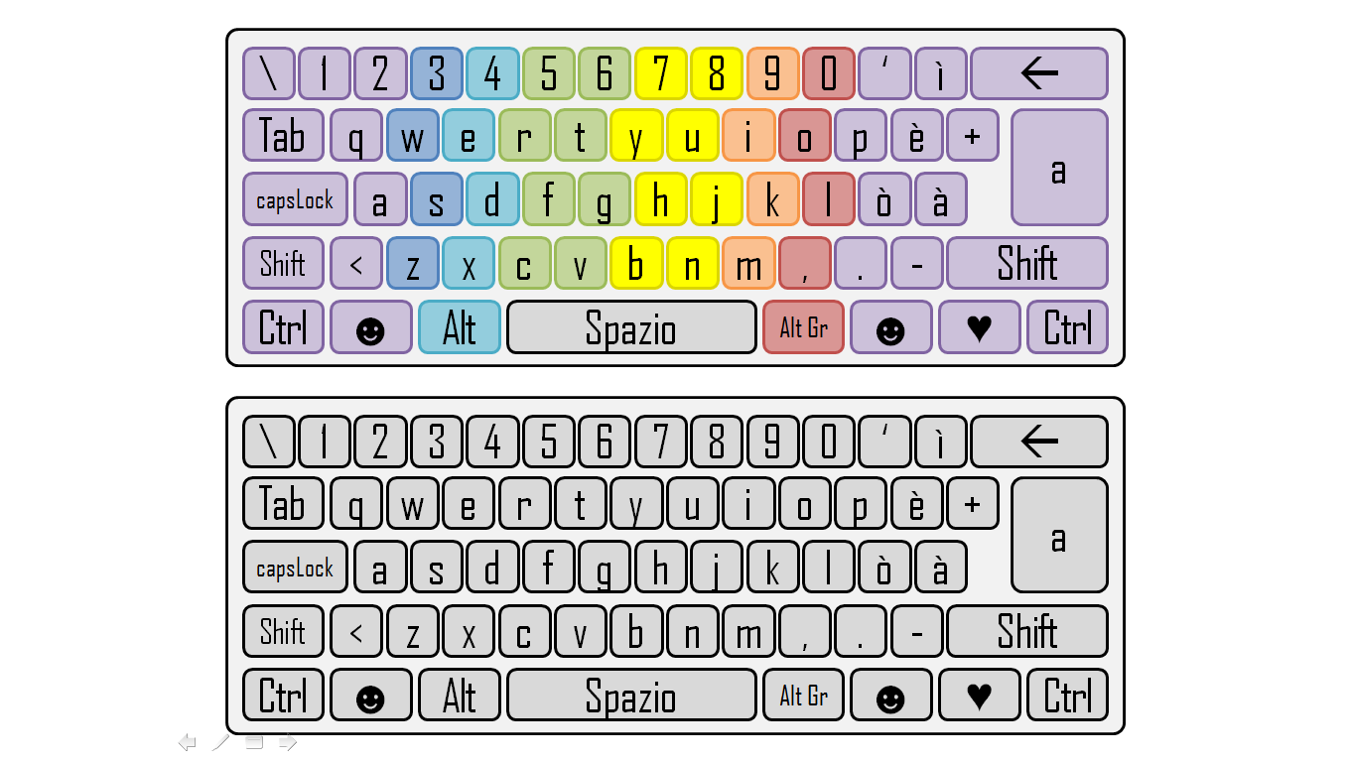

**Behavior:**

The keyboard used in easy mode is the first one (the colored one), every color corresponds to a finger [The legend will be drawn later]. The second one is used in medium mode. When a key is clicked, if it is the correct key to press, becomes green (and makes a BIP sound) else becomes red (and makes a WAHH sound). In easy mode the key you have to write is marked (it becomes white). When control key are pressed letters and symbols change (for example, if we press “Shift”, a becomes A, è becomes é, + becomes *, etc…).